# Time Palace Second Watch E-commerce

## 1. Project Overview

Time Palace Second Watch E-commerce is a modern platform designed to help luxury watch enthusiasts easily explore and reserve high-quality pre-owned timepieces. Although the project was initially created as a professional portfolio, it was built with a solid architectural foundation that allows it to be developed into a real product in the future.

The inspiration for this project came from a common issue in the second-hand watch market—many buyers struggle to find watches that are actually available or match the expected condition. Time Palace provides a solution through a product reservation system, enabling users to reserve watches that are not currently in-store so they can view them once available. This saves time and increases transparency throughout the buying experience.

Additionally, administrators have access to a dashboard that tracks conversion rates between reservations and sales, allowing them to analyze business performance and demand trends in real time.

From a technical perspective, the project highlights the use of Next.js 15 with Server-Side Rendering (SSR) to support SEO and loading speed. It also features dynamic filtering, where any newly added brand or product automatically appears in the filter without manual configuration. This approach reflects the developer’s ability to build modular, scalable, and efficient systems with the integration of modern technologies such as Supabase and Material UI.

## 2. Tech Stack & Tools

### 2.1 Main Tech Stack

|  |  |  |  |
| --- | --- | --- | --- |
| Tech | Tools | Version | Reason |
| Front-end Framework | Next JS | 15.5.3 | It supports the App Router and Server Components, enabling a combination of SSR (Server-Side Rendering) and CSR (Client-Side Rendering) for high performance while remaining SEO-friendly.  Its modular structure also simplifies integration with Supabase and React Hook Form, keeping the codebase scalable and maintainable. |
| Back-end Framework | Next JS | 15.5.3 | Next.js also serves as the backend layer through the Route Handlers API, allowing API endpoints to be implemented directly within the project without requiring a separate server.  This approach makes the architecture more efficient, easy to deploy, and well-suited for mid-scale e-commerce applications that require rapid integration between the UI and data logic. |
| Code Language | Typescript | 5 | Provides strong type safety to prevent runtime errors and maintain consistency across components.  TypeScript also improves scalability and readability of the codebase, especially when working with numerous hooks, services, and API layers in Next.js. |
| Database | Supabase |  | Chosen as a Backend-as-a-Service (BaaS) solution that offers a database, authentication, and built-in APIs within a single ecosystem.  Supabase enables real-time data synchronization, making it ideal for features such as reservation status updates and dashboard monitoring without manual server configuration. |
| Database Language | PostgreSQL |  | It is a stable and powerful relational database that supports complex queries and relational integrity.  PostgreSQL is also directly compatible with Supabase, allowing seamless integration between the data model and the API without the need for an additional ORM. |
| Authentication and Authorization | Supabase |  | Utilizes Supabase Auth to provide a login and registration system with JWT-based authentication.  It integrates directly with the database and API layer, simplifying session management, access authorization, and data security without manual backend implementation. |
| Styling | Material UI | 7.3.5 | Used to build a consistent, responsive, and modern interface with ready-made components based on Google’s design system. |

### 2.2 Additional Libraries and Support Tools

1. TanStack Query (React Query): Buat ngatur data fetching dan caching biar UI selalu update tanpa reload manual.
2. Recharts: Dipakai buat nampilin grafik performa reservasi dan penjualan di dashboard.
3. Date-fns: Buat format dan manipulasi tanggal dengan cepat dan ringan.
4. Swiper: Buat bikin carousel dan slider interaktif di halaman produk dan banner.

## 3. System Architecture

### 3.1 User Flow

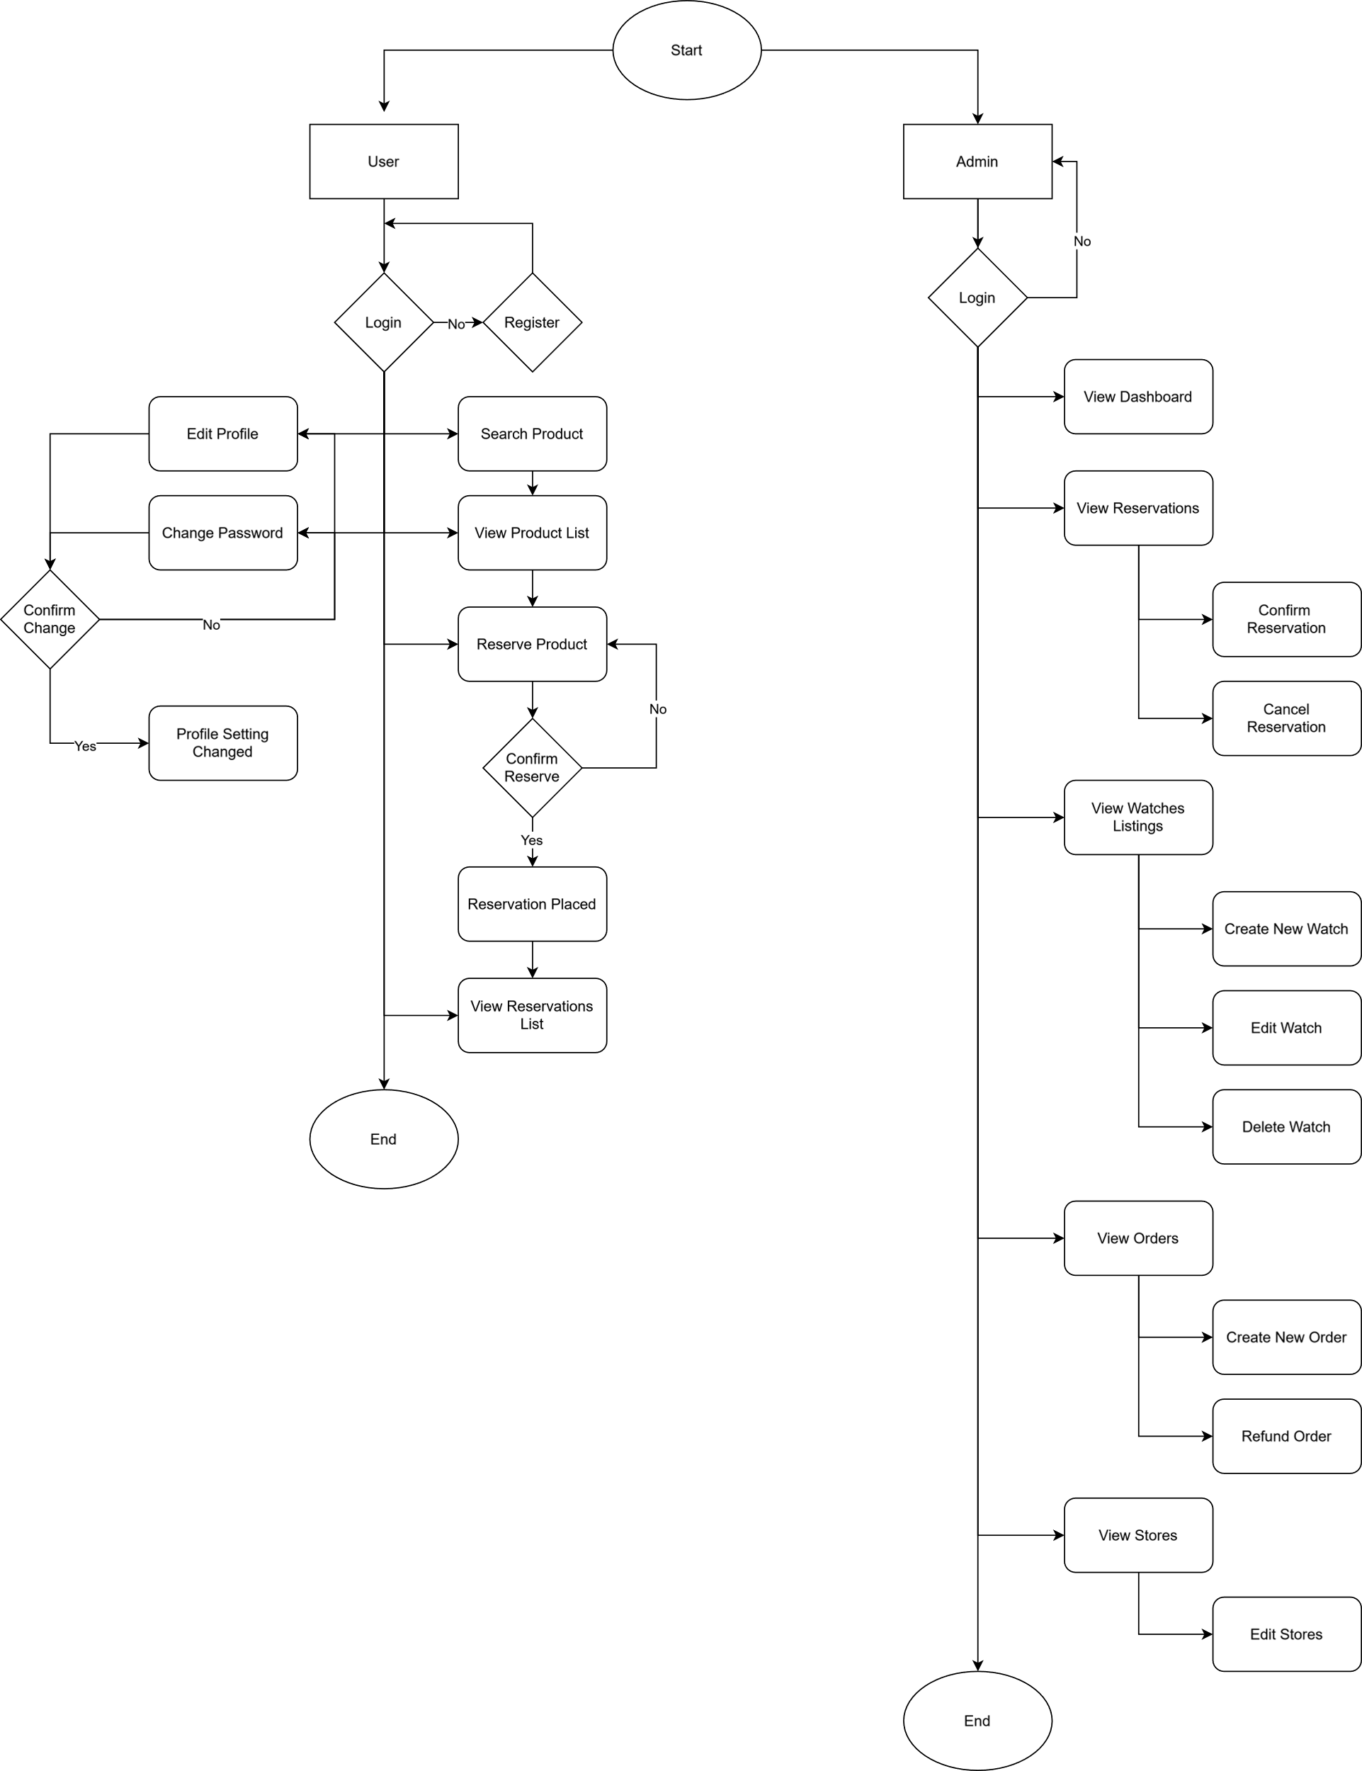

### 3.2 Folder Structure

|  |  |
| --- | --- |
| Folder Name | Description |
| _components | A folder containing reusable components that are organized using a feature-based approach. |
| _hooks | A folder containing custom hooks, primarily used to create React Query–based hooks. |
| _services | A folder containing Supabase API functions and the Supabase client initializer for both client-side and server-side environments. |
| _utils | A folder dedicated to utility functions, typically used for formatting values such as currency, display names, and other reusable value transformations. |
| _types | A folder that stores all type definitions, providing a centralized location for TypeScript type declarations. |
| _contants | A folder that contains global constants, including page size, enums, and conditional styling variables. |
| (dashboard) | A folder that contains routes for the admin pages. |
| (website) | A folder that contains routes for the client pages. |
| (signup) | A folder dedicated to the client signup page routes. |

**Admin Page Routes**

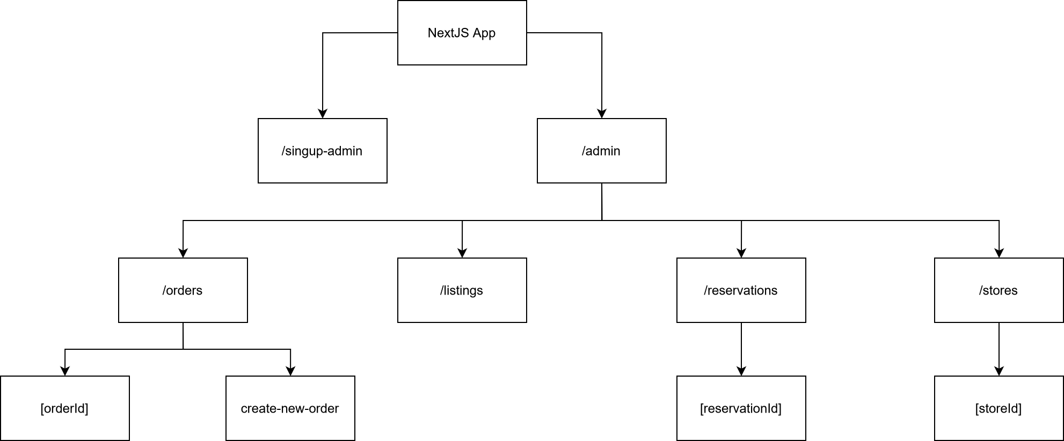

**Website Page Routes**

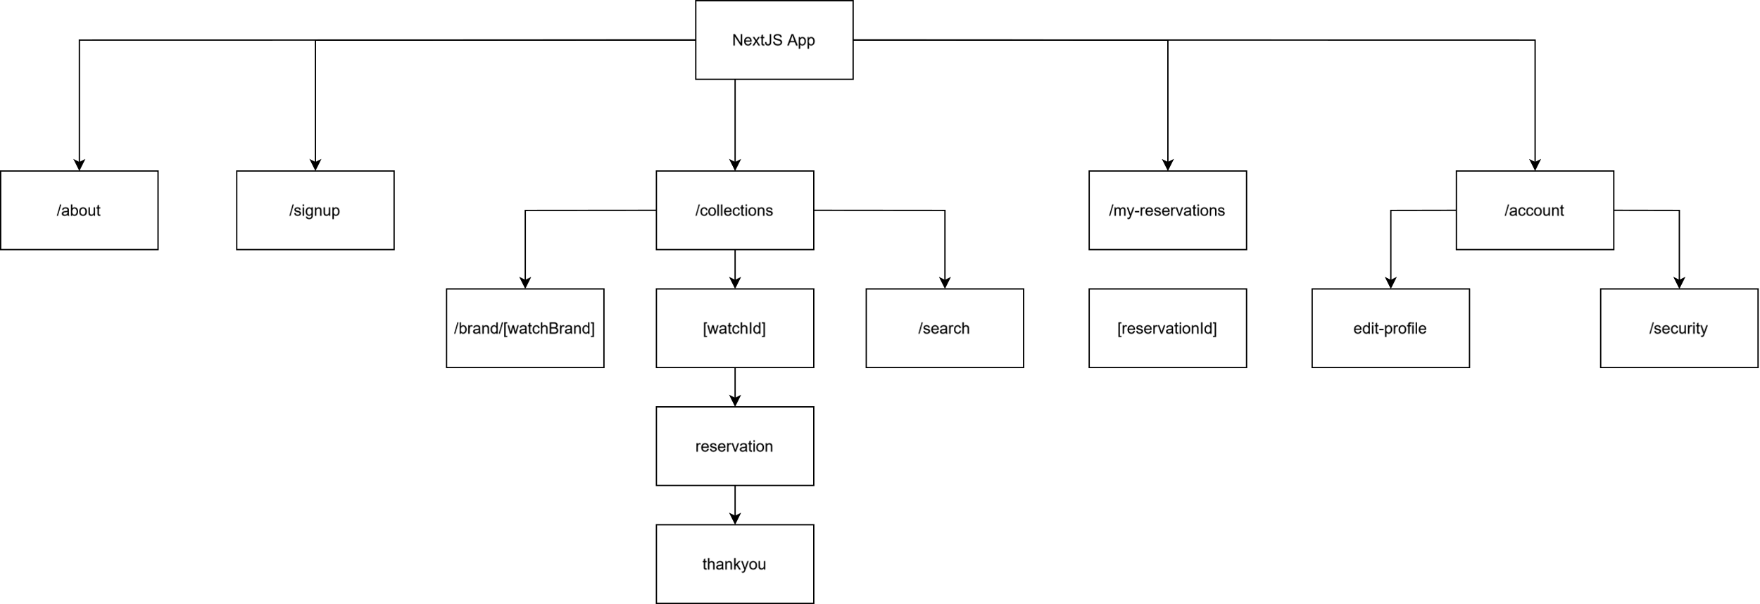

### 3.3 Database Structure

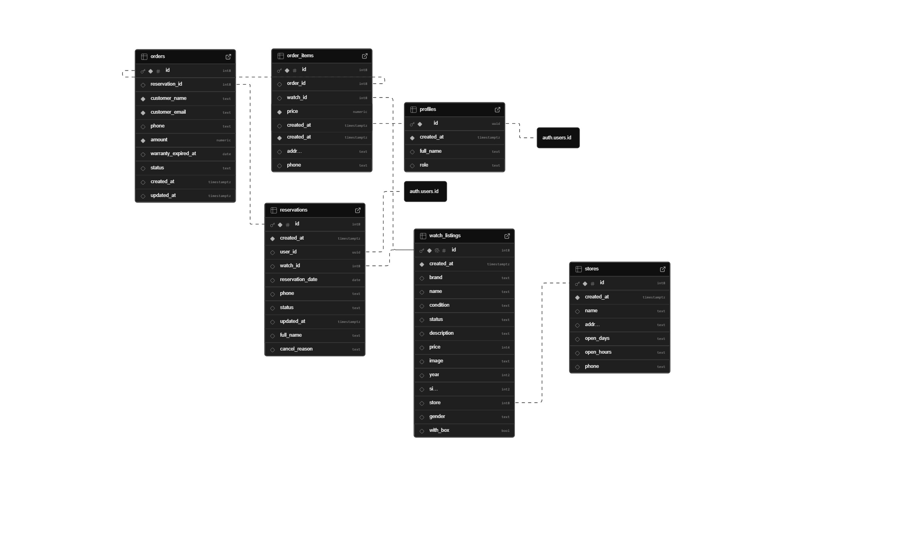

## 4. Core Features

### 4.1 Web Page Requirement

* About
  + Users can view the profile and all essential information about the e-commerce platform.
* Sign-Up
  + Users can create a new account.
  + Users can log in to the website.
  + Users can sign out of the website.
* Catalog
  + Users can view all available pre-owned watches.
  + Users can filter the catalog by brand, year, and price.
  + Users can sort the catalog by creation date, price, or alphabetical order, in both ascending and descending options.
  + Users can search for a watch by name.
  + Users can see search suggestions while typing in the search bar.
* Reservations
  + Users can view all of their reservations and their current statuses.
  + Users can reserve a watch if the selected date is available.
  + Users cannot reserve a watch if it has already been booked for that specific date.
  + Users cannot make duplicate reservations for the same watch on the same day.
* Account
  + Users can edit their profile and update their password.

### 4.2 Admin Page Requirement

* Sign-Up
  + Admins can log in to the admin page if authorized.
  + Admins can log out of the admin page.
* Orders
  + Admins can view a table containing all orders.
  + Admins can filter the table by order status.
  + Admins can sort the table by order date and amount, both in ascending and descending order.
  + Admins can search for orders by the customer’s name.
  + Admins can create new orders
* Listings
  + Admins can view a table of all watch listings.
  + Admins can filter the listings by watch status, condition, and brand.
  + Admins can sort the listings by date, name, and price.
  + Admins can search for a specific watch by name.
  + Admins can add new watches to the listings.
  + Admins can perform actions such as viewing details, editing, and deleting a watch.
  + Pagination is implemented.
* Reservations
  + Admins can view a table of all reservations.
  + Admins can filter reservations by status.
  + Admins can sort reservations by date in ascending or descending order.
  + Admins can perform actions such as viewing details, confirming, or canceling a reservation.
  + Pagination is implemented.
* Stores
  + Admins can view a table of all stores.
  + Admins can view and edit detailed store information.
* Dashboard
  + Admins can view total sales, total orders, and total new users for selected periods (last 7 days, 30 days, or 90 days).
  + Admins can view a pie chart showing total items sold by brand for selected periods (last 7 days, 30 days, or 90 days).
  + Admins can quickly view pending reservations and take immediate action.
  + Admins can review the top 10 most-reserved items for selected periods (last 7 days, 30 days, or 90 days).
  + Admins can view bar chart data showing total revenue and active reservations for each brand over selected periods (last 7 days, 30 days, or 90 days).

### 4.3 Features Challenge and Solution

#### 4.3.1 Dynamic Filter

Challenge: Initially, brand and category filters had to be configured manually every time a new product was added, making updates cumbersome and prone to errors.

Solution: The filters were redesigned to be fully data-driven. Whenever a new brand or category is added to the database, the Filter component automatically fetches all available brands and generates the options dynamically. The filter also disables the brand option when the user is on the /collections/[brand] route to prevent redundant selections.

#### Data Fetching for Server and Client Component

Challenge: Supabase requires different handling between Server Components and Client Components in Next.js. Using a single initialization causes session issues—cookies may not persist on the server, and localStorage is not available in the server environment.

Solution: Supabase initialization was split into two separate clients:

* + 1. A browser client used within Client Components for interactive operations, relying on localStorage for session management.
    2. A server client used within Server Components and API routes, maintaining sessions through cookies handled by Next.js.

This separation ensures that each environment manages authentication and data fetching using the correct mechanisms without conflicts.

#### Data Fetching Optimization with React Query

Challenge: The admin pages require continuously updated data (such as orders, product listings, and transaction statuses) while remaining efficient and avoiding repeated fetch operations. A manual approach using useEffect and direct fetch calls leads to inconsistent data across components, limited control over caching, and no automatic invalidation after update or delete actions.

Solution: React Query is used as the primary data-fetching layer across all admin pages. It manages caching, automatically refetches stale data, and simplifies cache invalidation after mutations. Each endpoint (such as orders or watch_listings) is wrapped in custom hooks like useOrders() or useWatchListings(). This ensures that data in the admin pages remains consistent, efficient, and easily refreshed without manual API calls.

#### SEO and Performance with Server-Side Rendering (SSR)

Challenge: Public-facing pages such as the homepage, product listings, and product detail pages must be properly indexed by search engines. However, if data is fetched only on the client using React hooks, the main content does not exist during initial page load. As a result, crawlers like Googlebot may see an empty or loading page, lowering SEO ranking and slowing down time-to-content.

Solution: Server-Side Rendering (SSR) is applied to public pages that are critical for SEO. With SSR, data is fetched on the server before the page is sent to the browser, ensuring that the HTML delivered already contains the complete content. This allows search engine crawlers to read all text and metadata correctly while improving First Contentful Paint (FCP) and Core Web Vitals. This approach can still be combined with client-side hydration to preserve full React interactivity after the initial render.

## 5. Code Highlights

### 5.1 Supabase Client Initialization

Server.ts

import { createServerClient } from "@supabase/ssr";

import { cookies } from "next/headers";

export async function createClient() {

const cookieStore = await cookies();

return createServerClient(

process.env.NEXT_PUBLIC_SUPABASE_URL!,

process.env.NEXT_PUBLIC_SUPABASE_KEY!,

{

cookies: {

getAll() {

return cookieStore.getAll();

},

setAll(cookiesToSet) {

try {

cookiesToSet.forEach(({ name, value, options }) =>

cookieStore.set(name, value, options)

);

} catch {

// The `setAll` method was called from a Server Component.

// This can be ignored if you have middleware refreshing

// user sessions.

}

},

},

}

);

}

Client.ts

import { createBrowserClient } from "@supabase/ssr";

export function createClient() {

return createBrowserClient(

process.env.NEXT_PUBLIC_SUPABASE_URL!,

process.env.NEXT_PUBLIC_SUPABASE_KEY!

);

}

### 5.2 React Query Integration untuk Admin Page

useUpdateOrderStatus()

export const useUpdateOrderStatus = () => {

const queryClient = useQueryClient();

return useMutation({

mutationFn: async (vars: {

orderId: number;

status: "completed" | "refunded";

}) => {

return updateOrderStatus(vars.orderId, vars.status);

},

onSuccess: () => {

queryClient.invalidateQueries({ queryKey: ["orders"] });

},

onError: (err) => {

console.error

},

});

};

useWatchListings()

export function useWatchListings(storeId?: number) {

const queryClient = useQueryClient();

const searchParams = useSearchParams();

const brand = searchParams.get("brand");

const condition = searchParams.get("condition");

const status = searchParams.get("status");

const sortBy = (searchParams.get("sortBy") as SortOption) || undefined;

const page = !searchParams.get("page") ? 1 : Number(searchParams.get("page"));

const keyword = searchParams.get("q") || "";

const filters: AdminWatchFilters = {

brand: brand && brand !== "all" ? brand.split(",") : [],

condition: condition && condition !== "all" ? condition.split(",") : [],

status: status && status !== "all" ? status.split(",") : [],

};

const queryKey = storeId

? ["watch_listings_by_store", storeId, filters, sortBy, page, keyword]

: ["watch_listings", filters, sortBy, page, keyword];

const {

data: { data: listings = [], count = 0 } = {},

isLoading,

error,

} = useQuery({

queryKey,

queryFn: () =>

storeId

? getWatchListingsByStore(storeId, filters, sortBy, page, keyword)

: getAllWatchListings(filters, sortBy, page, keyword),

});

const pageCount = Math.ceil(count / PAGE_SIZE);

if (page < pageCount) {

queryClient.prefetchQuery({

queryKey: storeId

? ["watch_listings_by_store", storeId, filters, sortBy, page + 1]

: ["watch_listings", filters, sortBy, page + 1],

queryFn: () =>

storeId

? getWatchListingsByStore(storeId, filters, sortBy, page + 1, keyword)

: getAllWatchListings(filters, sortBy, page + 1, keyword),

});

}

if (page > 1) {

queryClient.prefetchQuery({

queryKey: storeId

? ["watch_listings_by_store", storeId, filters, sortBy, page - 1]

: ["watch_listings", filters, sortBy, page - 1],

queryFn: () =>

storeId

? getWatchListingsByStore(storeId, filters, sortBy, page - 1, keyword)

: getAllWatchListings(filters, sortBy, page - 1, keyword),

});

}

return { listings, count, isLoading, error, page };

}

## 6. Design

Desain Time Palace dibuat dengan prinsip clean, modern, dan responsive supaya nyaman digunakan di semua perangkat, terutama mobile.

UI dibangun dengan Material UI (MUI) yang punya sistem grid dan breakpoint bawaan, jadi layout bisa otomatis menyesuaikan ukuran layar tanpa CSS tambahan.

Semua komponen utama seperti product card, navbar, dan dashboard disusun ulang agar tetap rapi dan mudah digunakan di layar kecil — teks tetap terbaca, tombol proporsional, dan navigasi tetap jelas.

Pendekatan ini bikin proses styling lebih cepat, konsisten, dan gampang di-maintain karena semuanya diatur langsung lewat tema global MUI.

### 6.1 Web Page

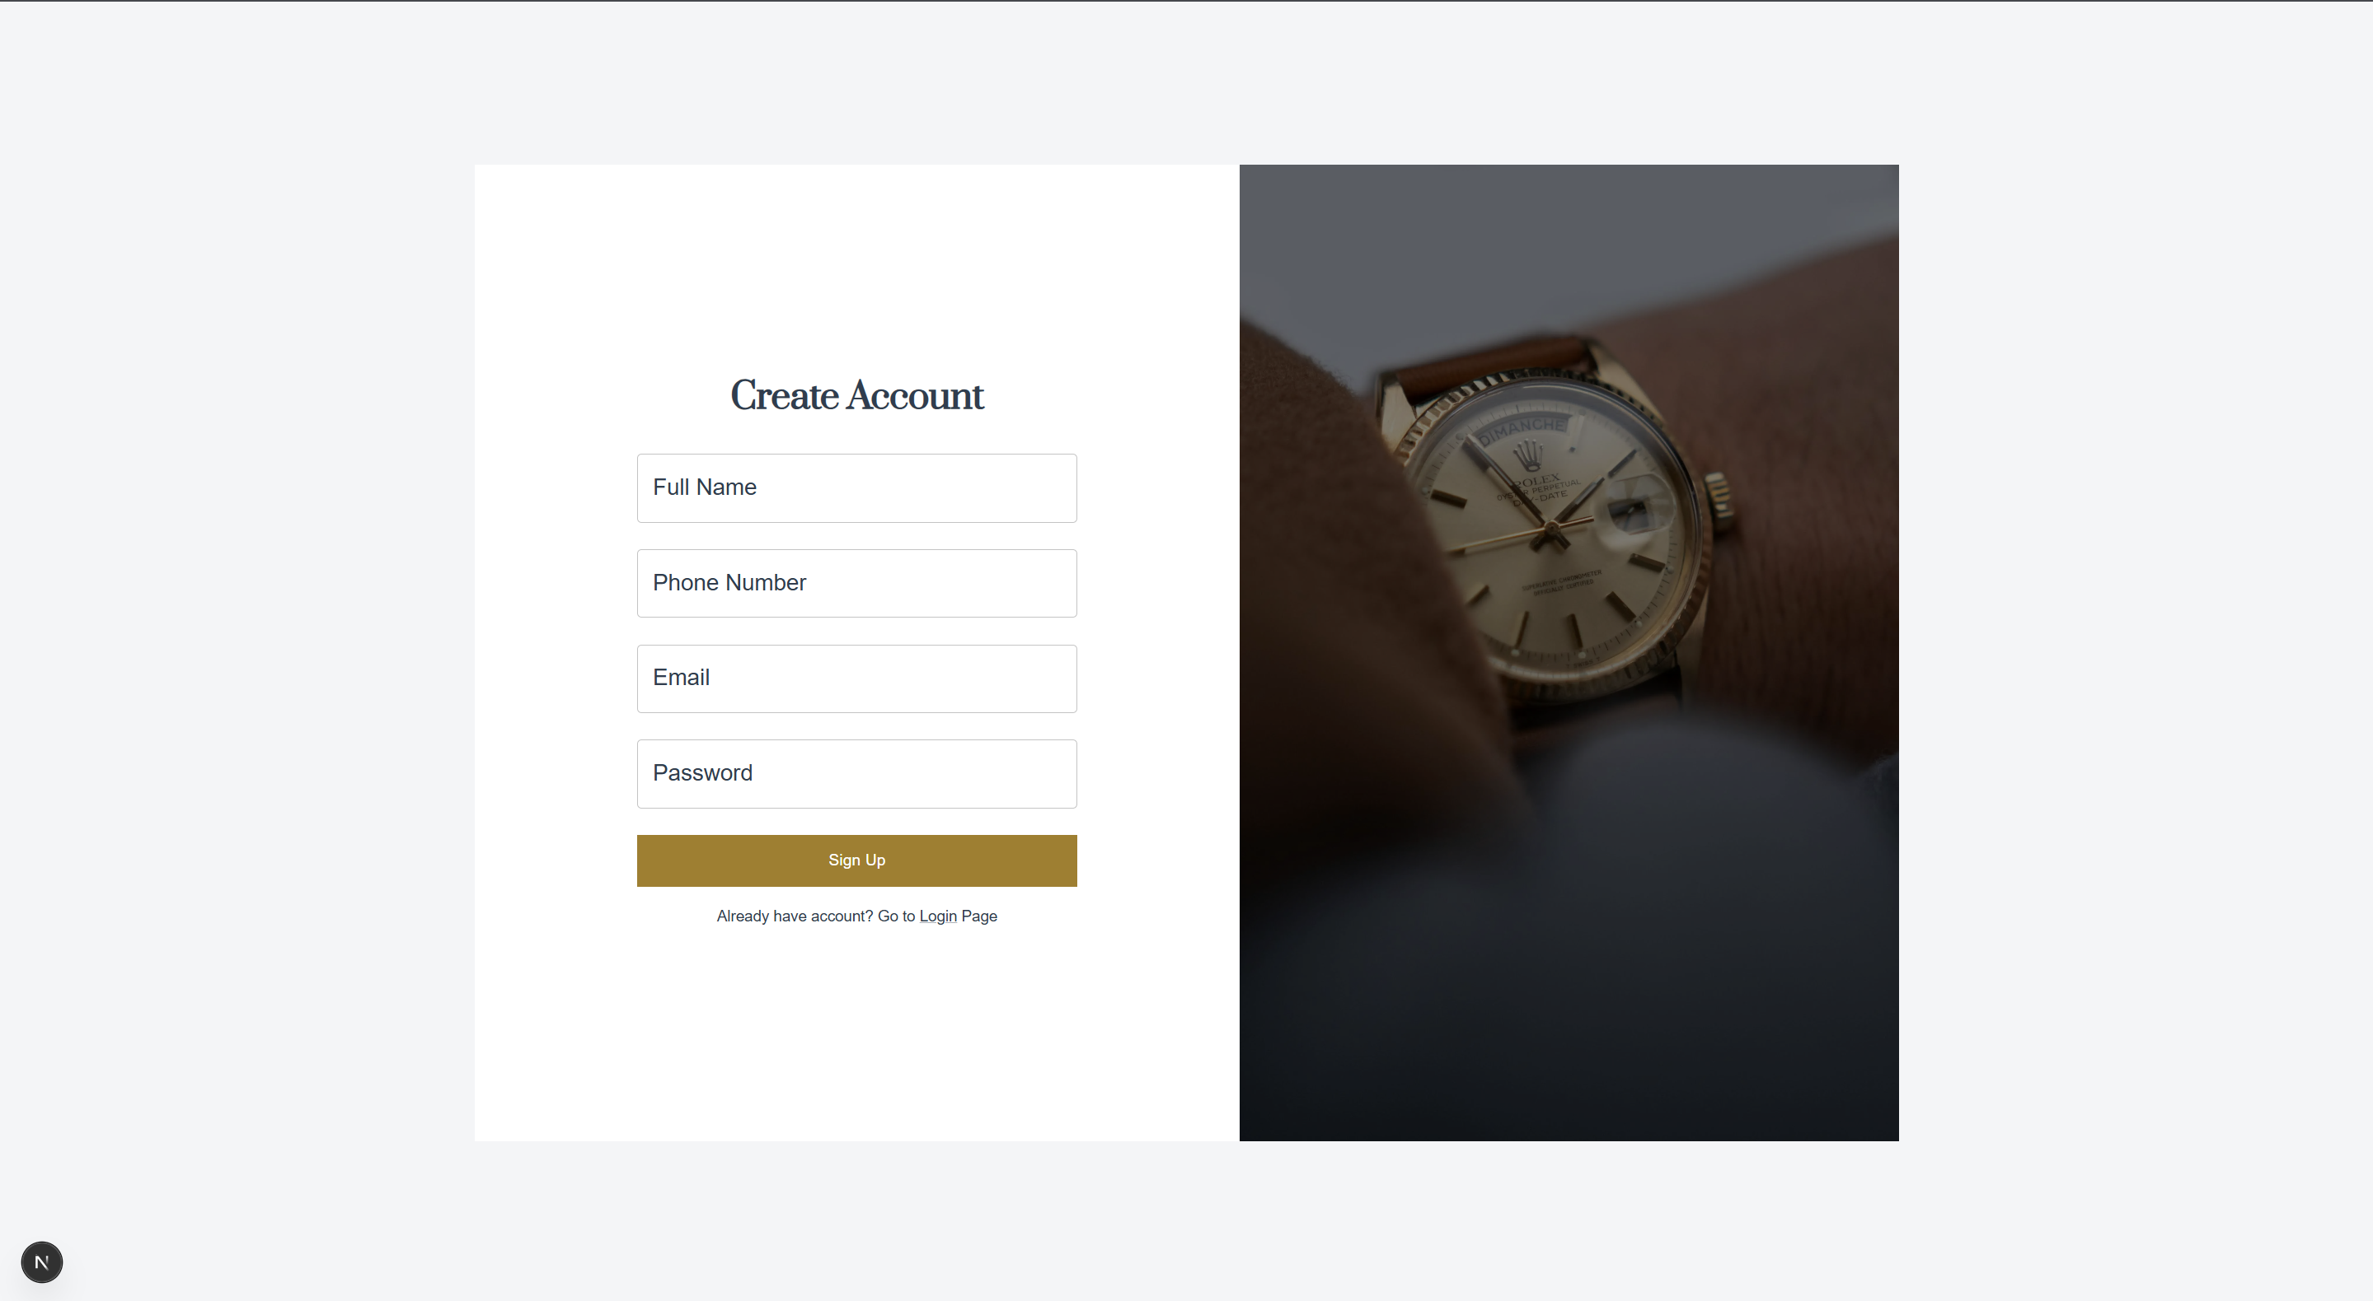 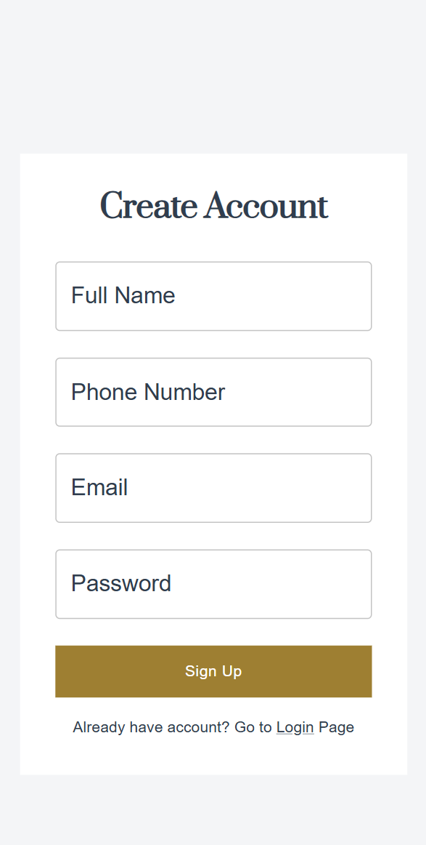

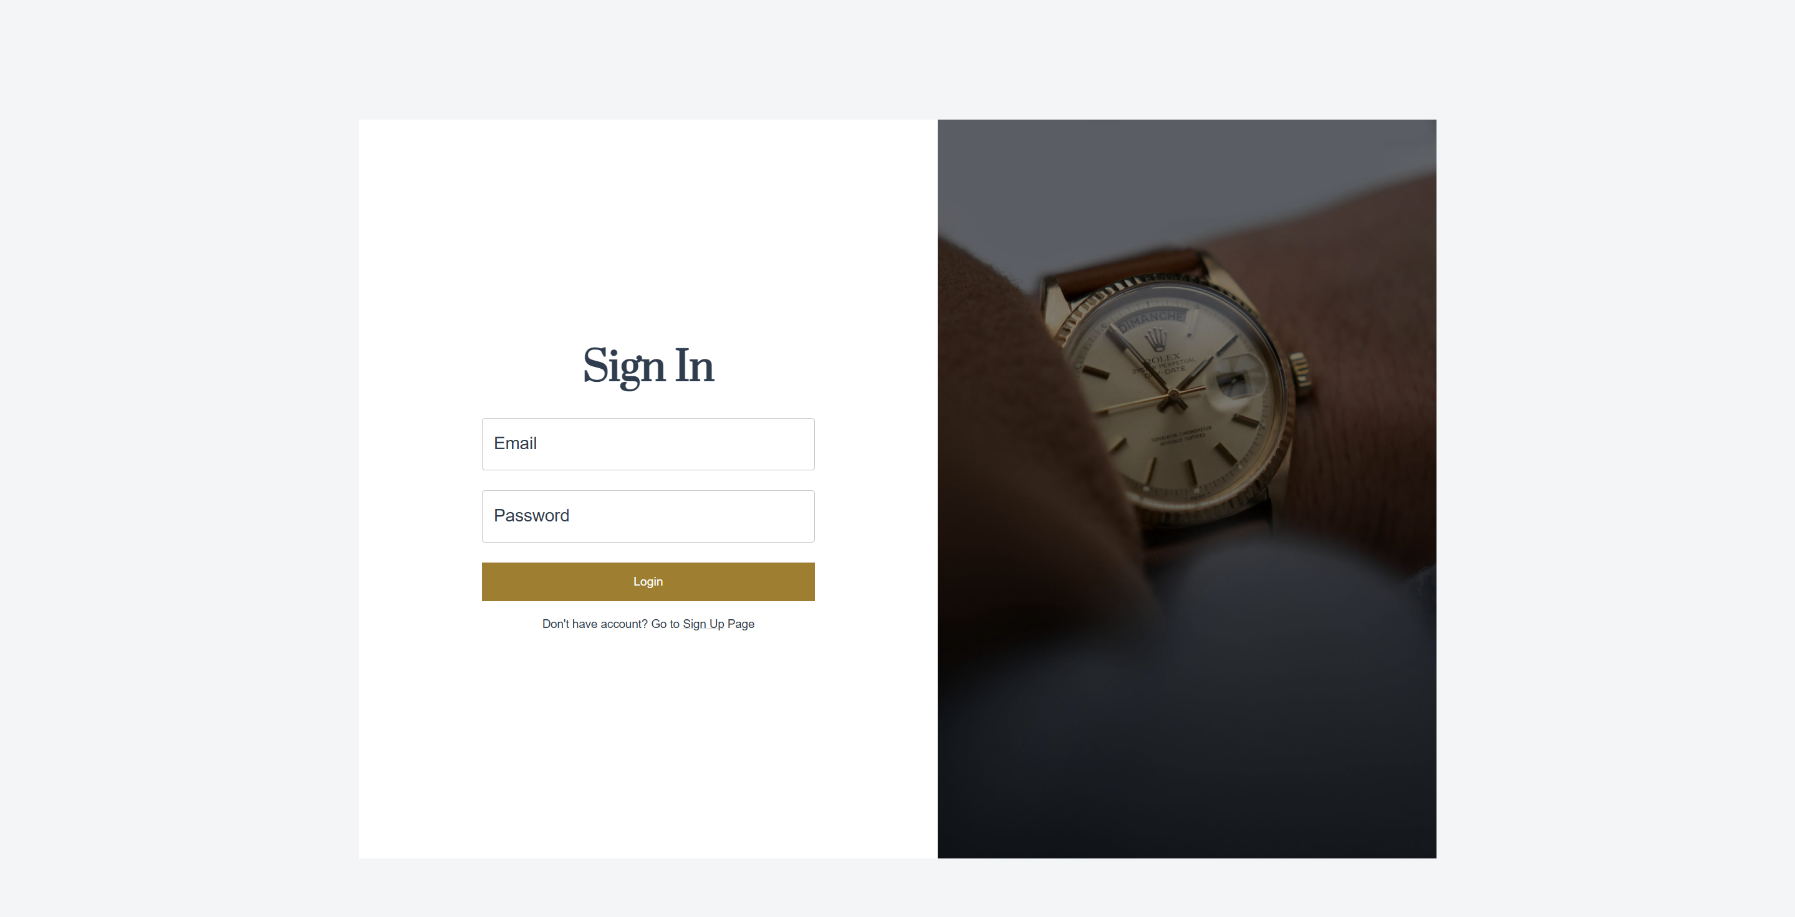 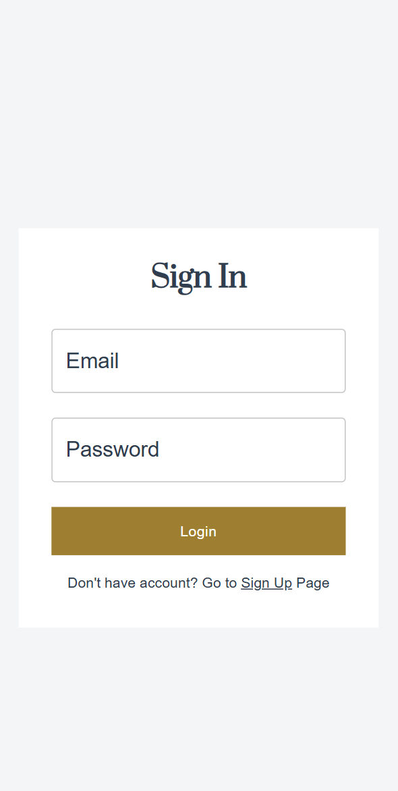

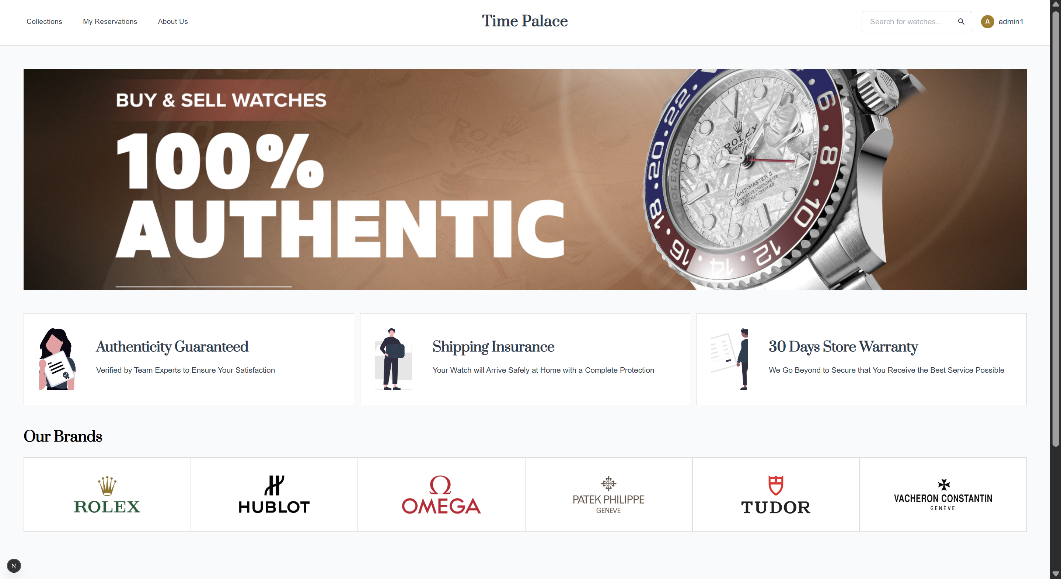

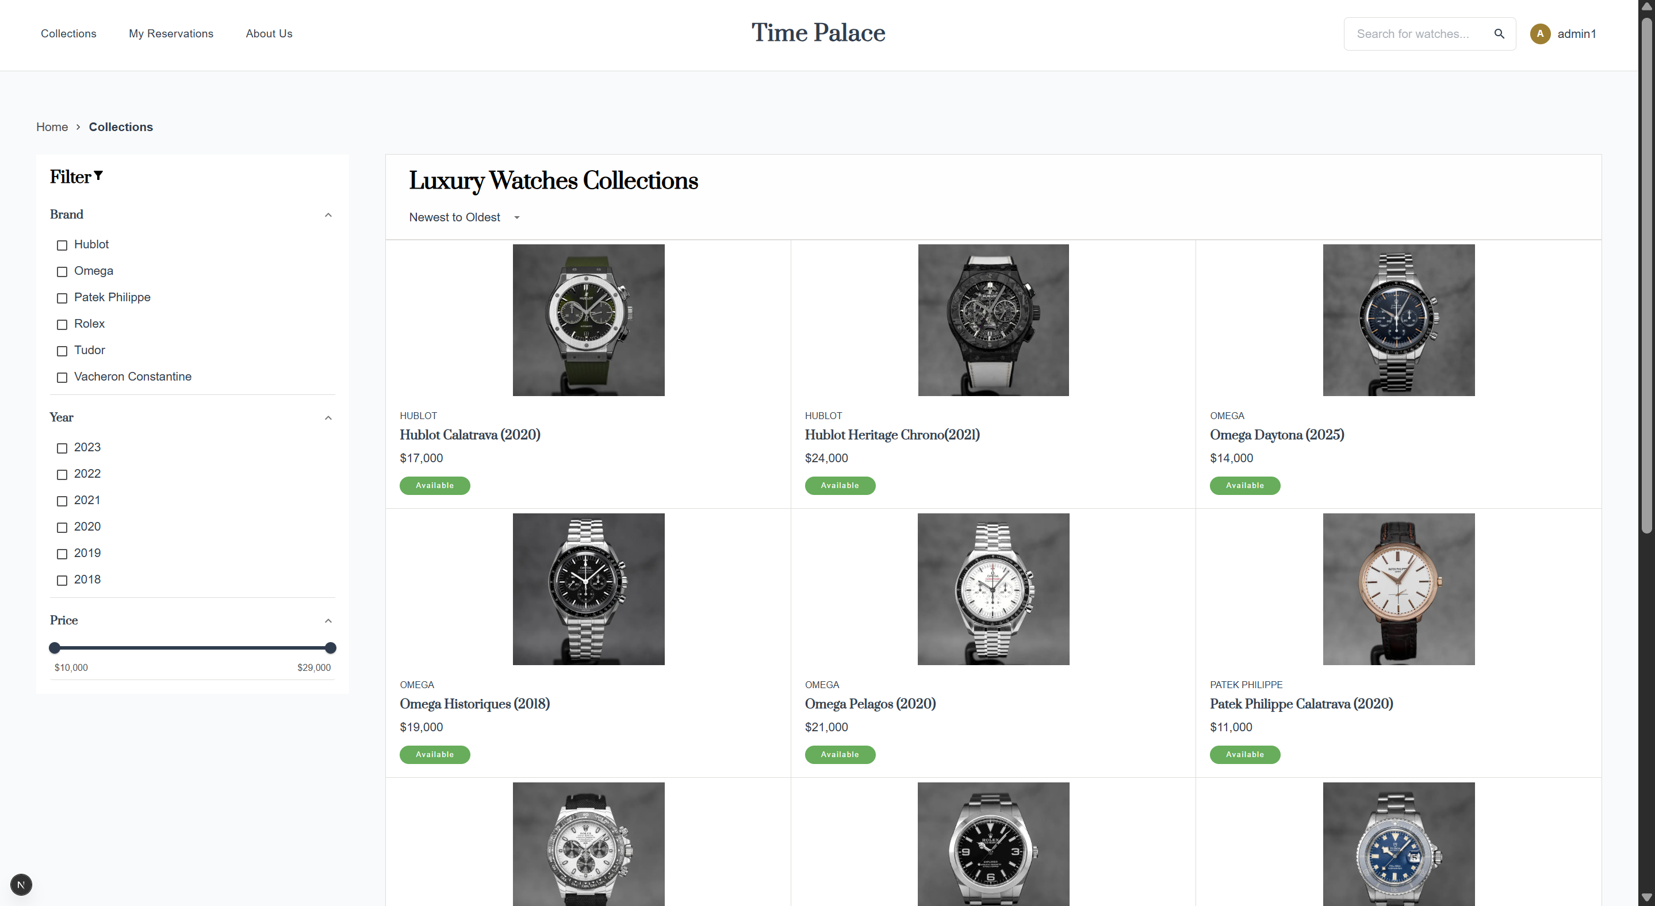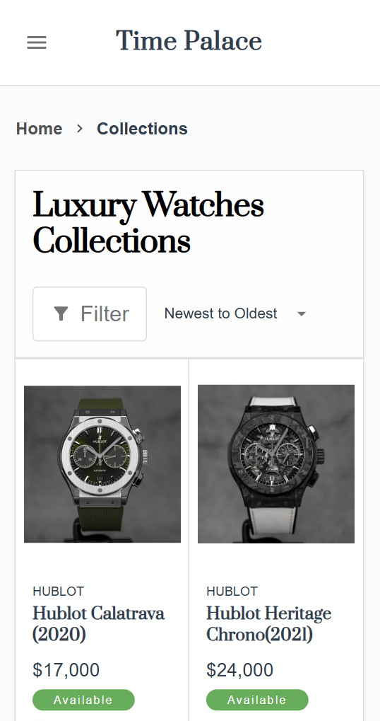

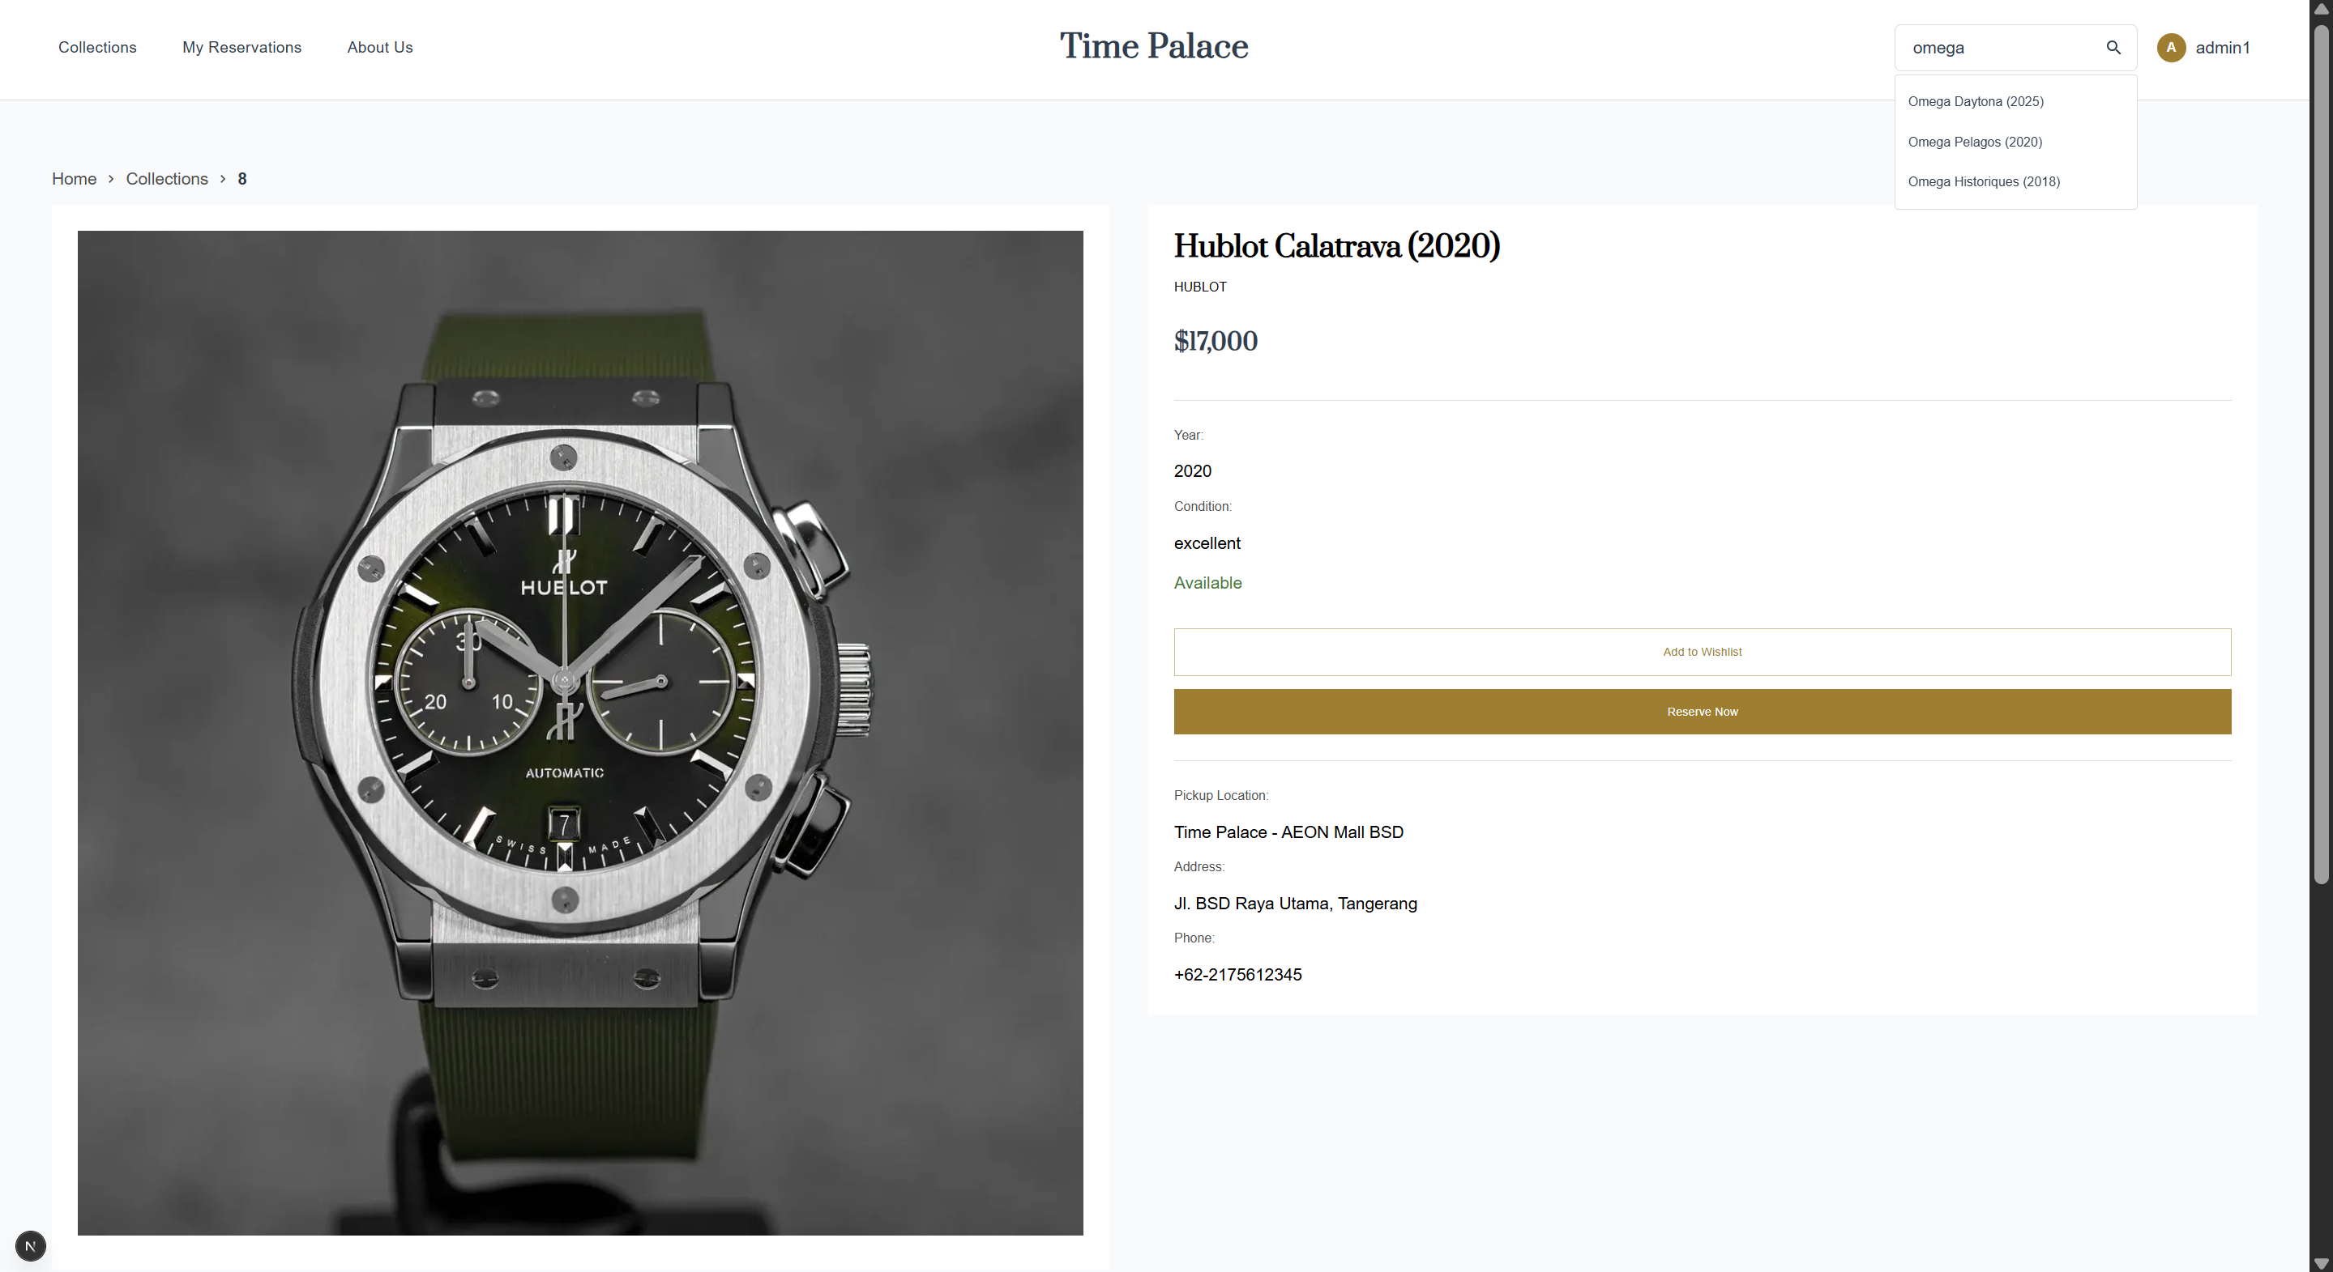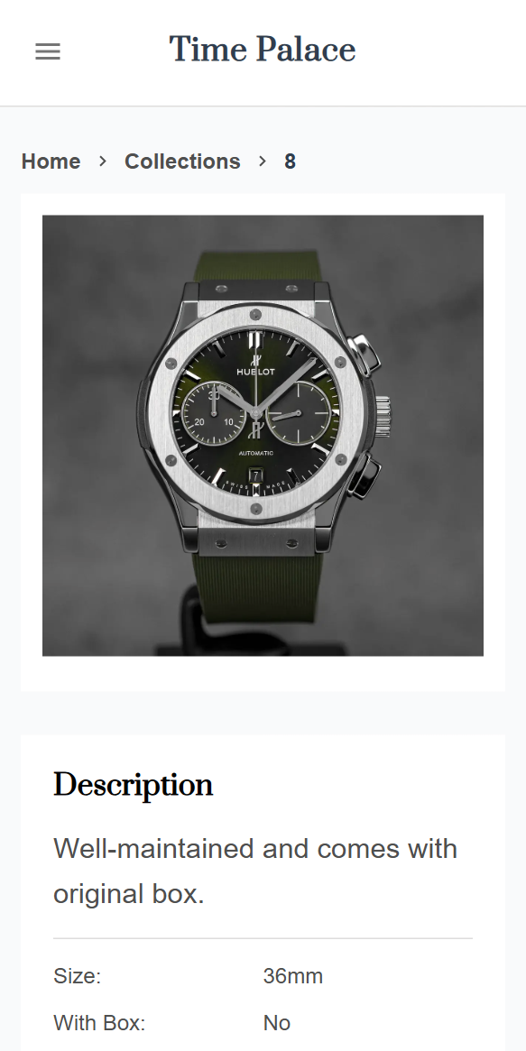

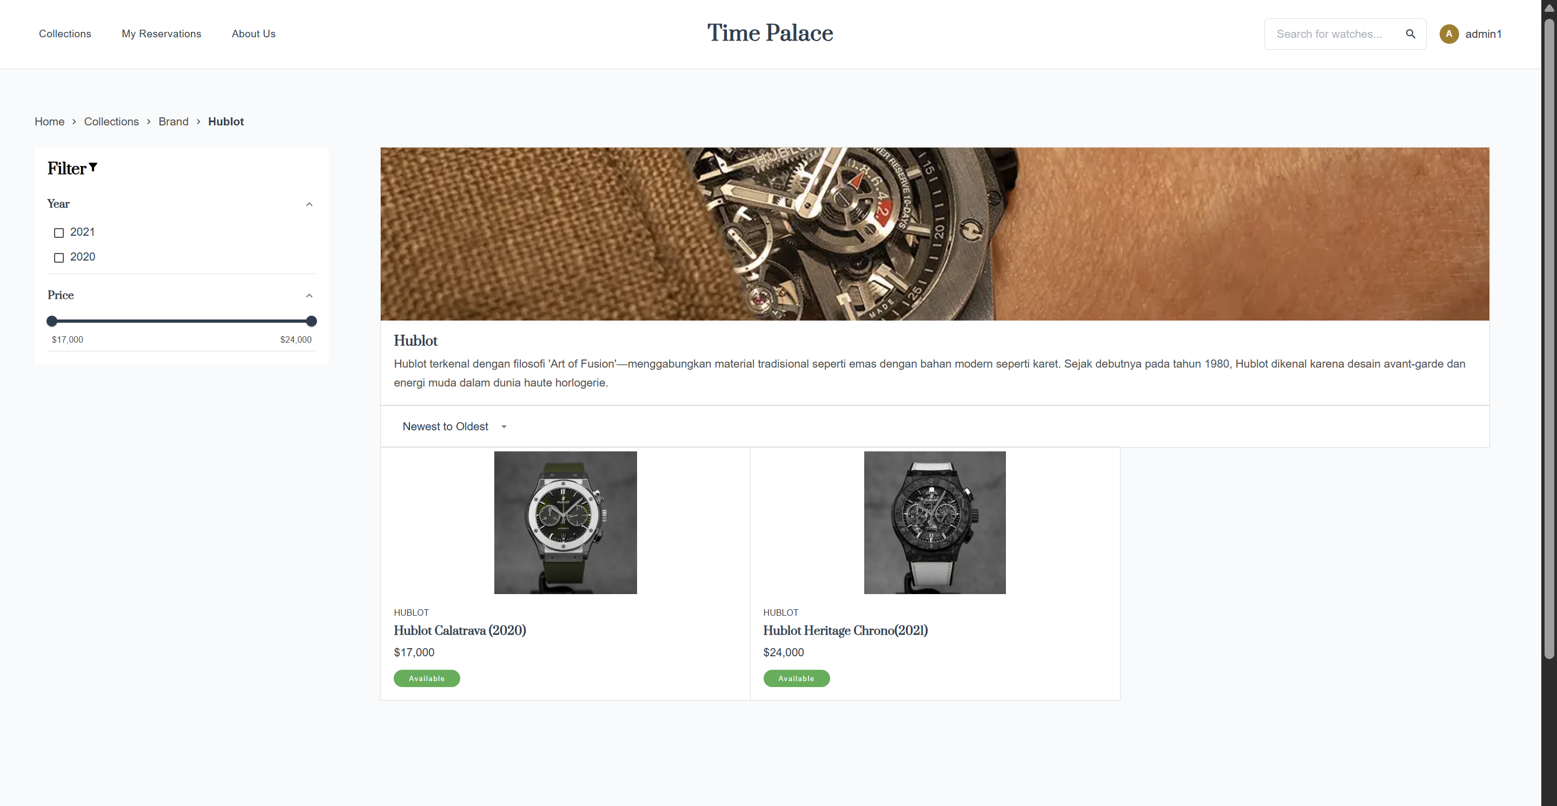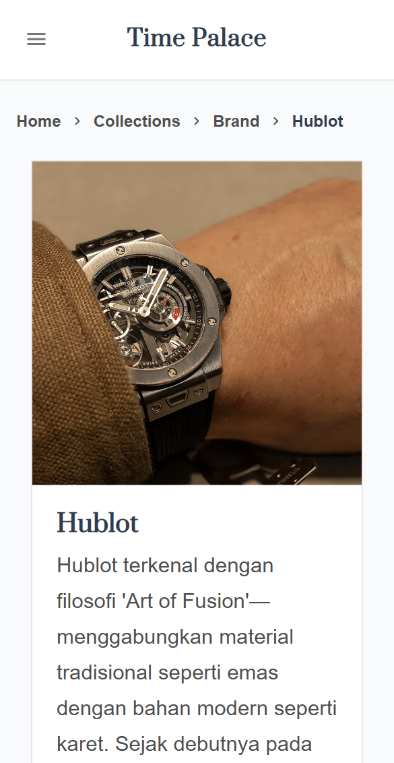

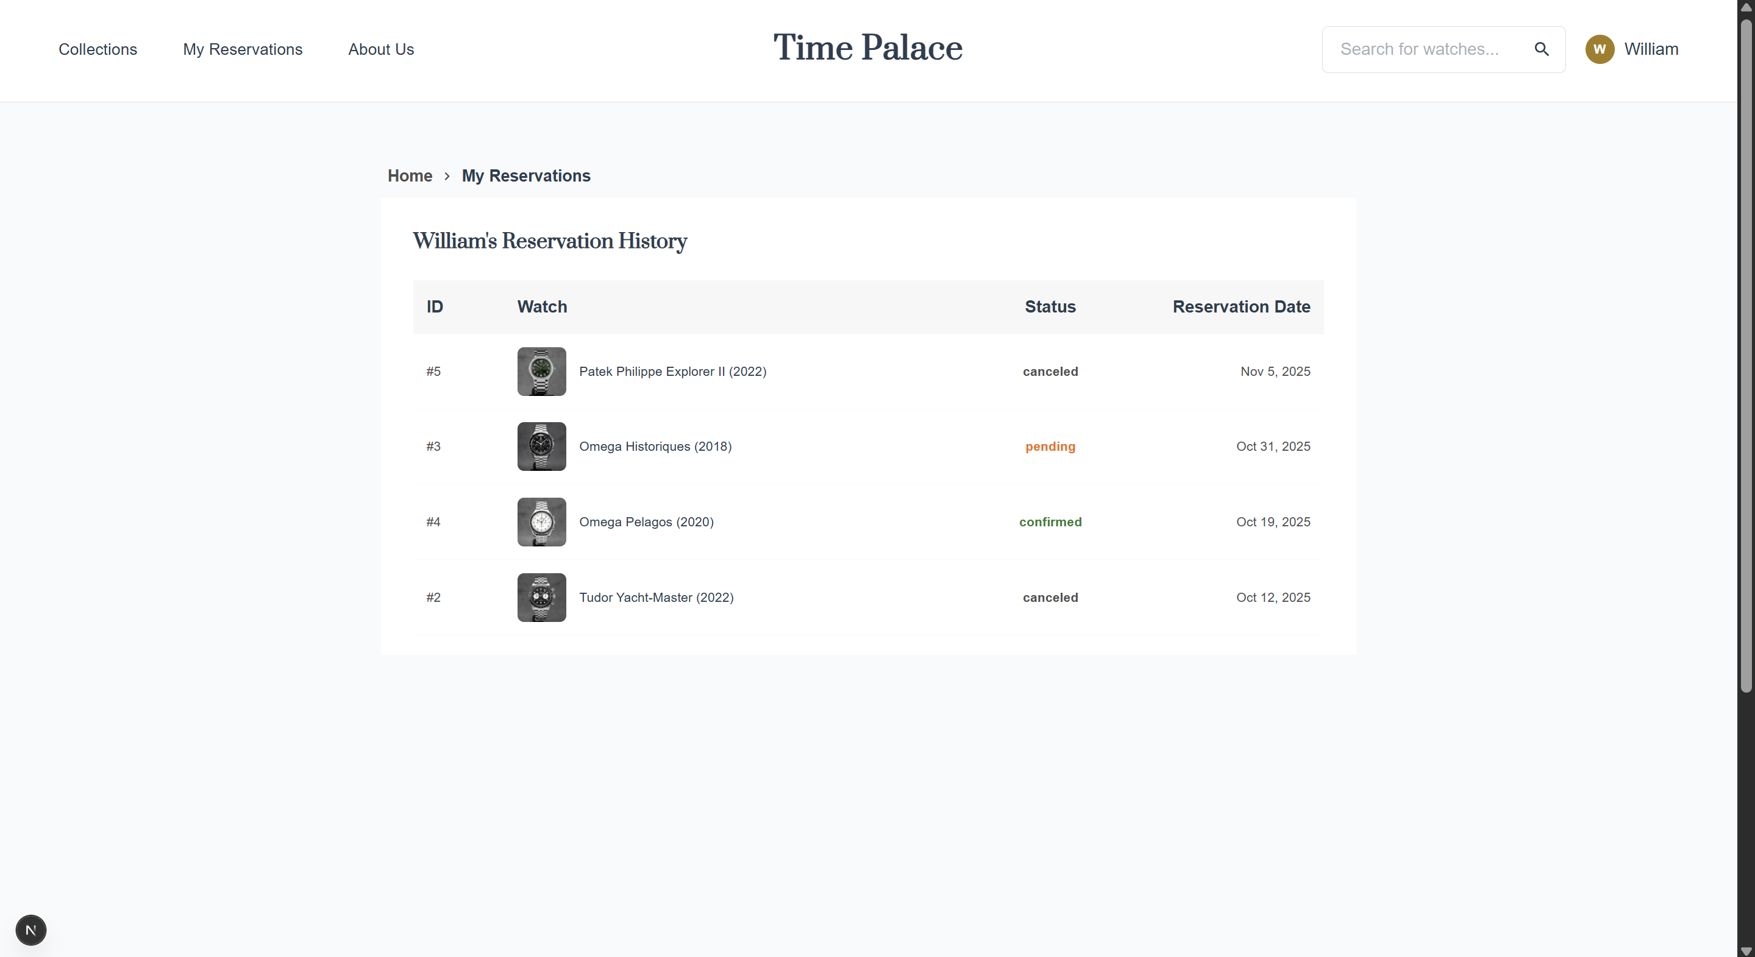 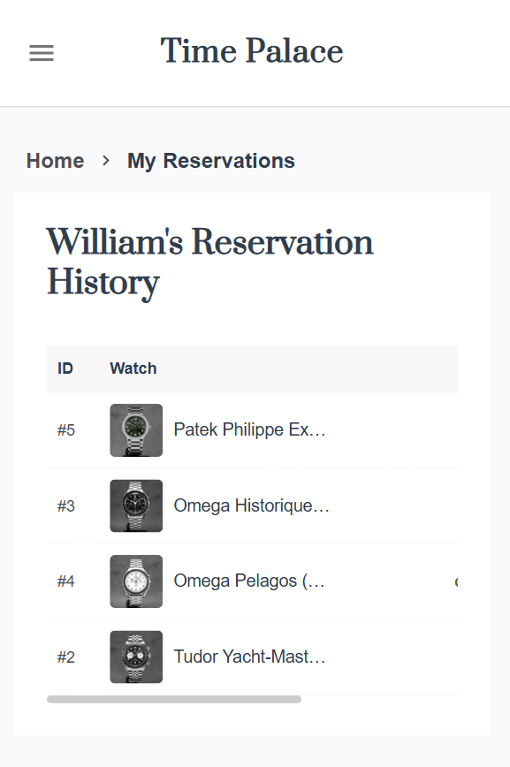

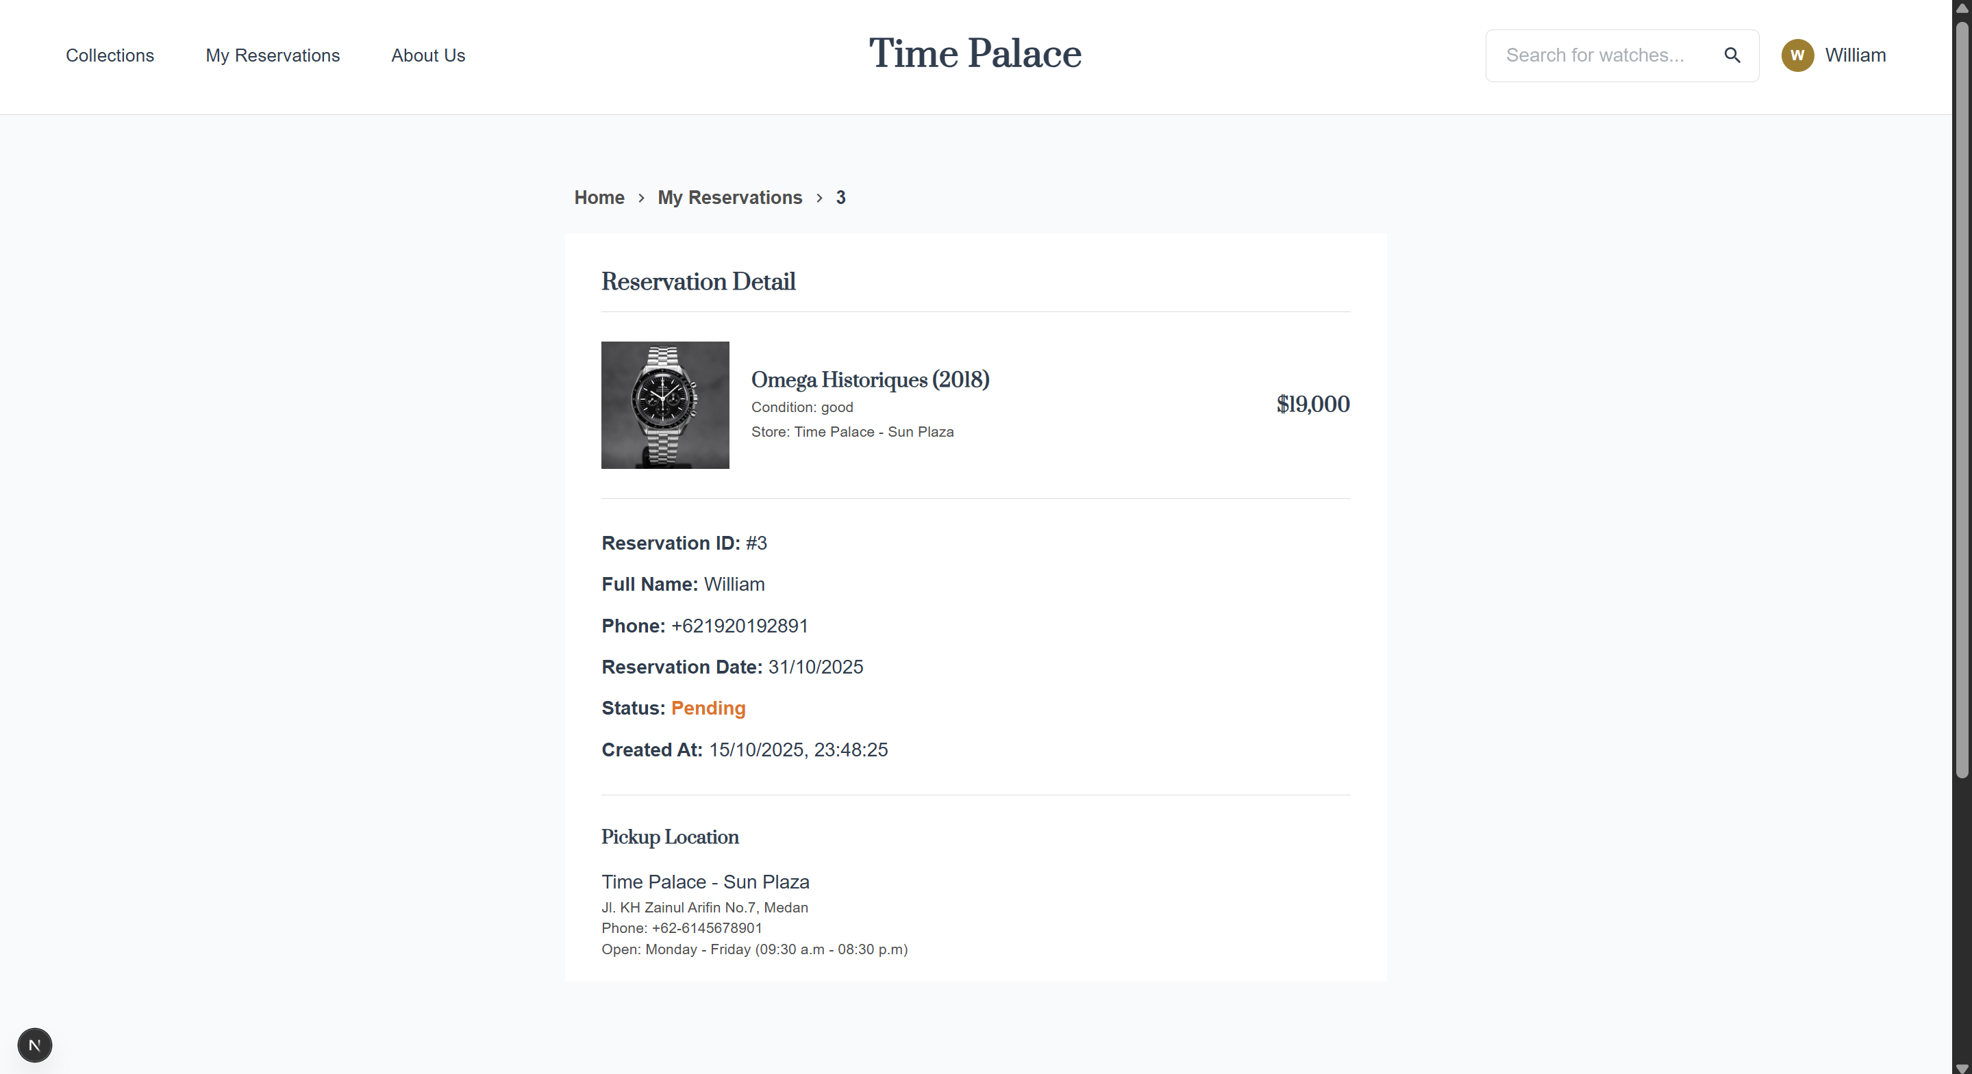 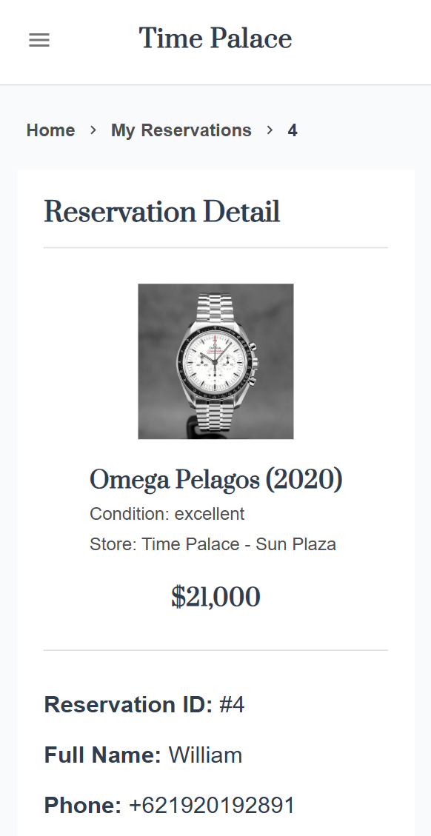

### 6.2 Admin Page

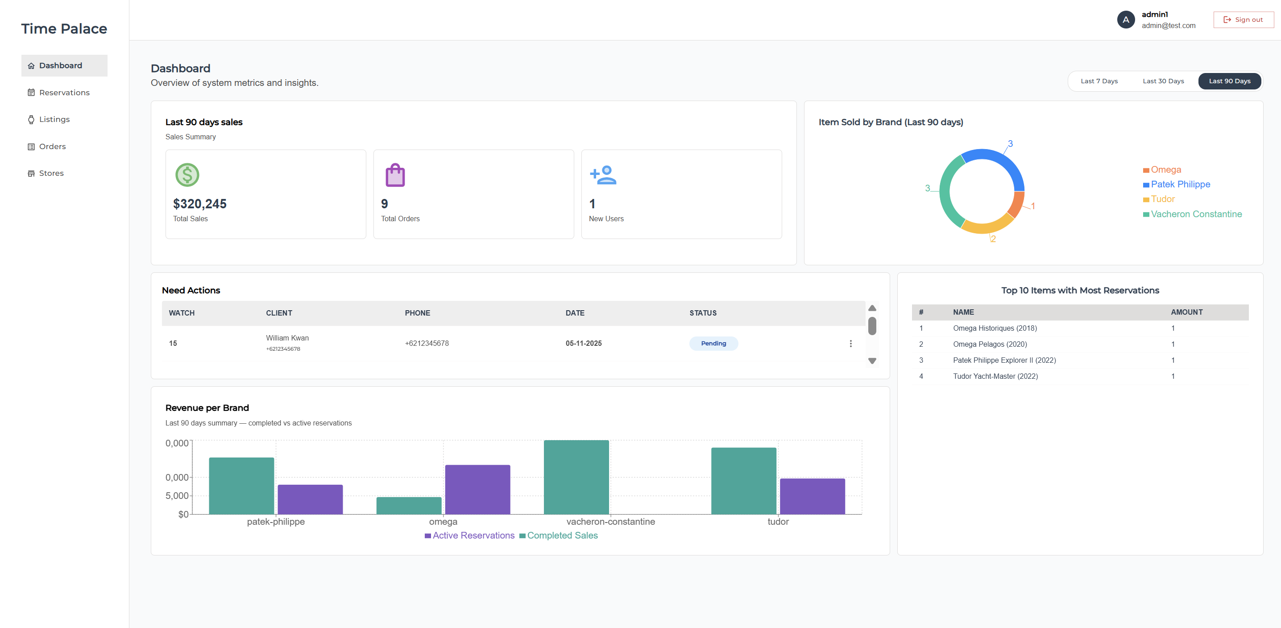

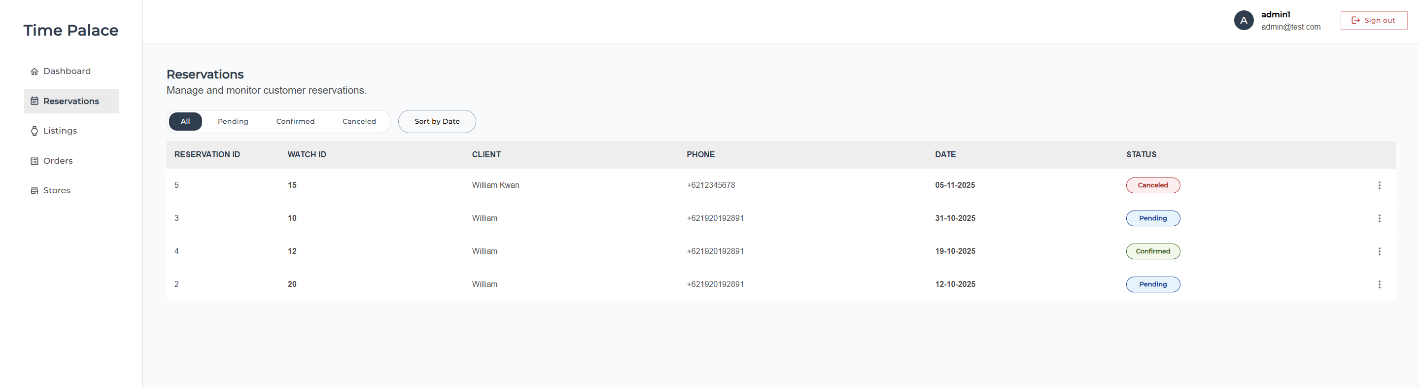

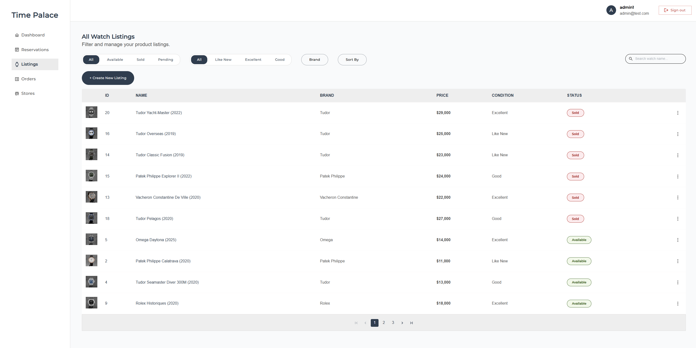

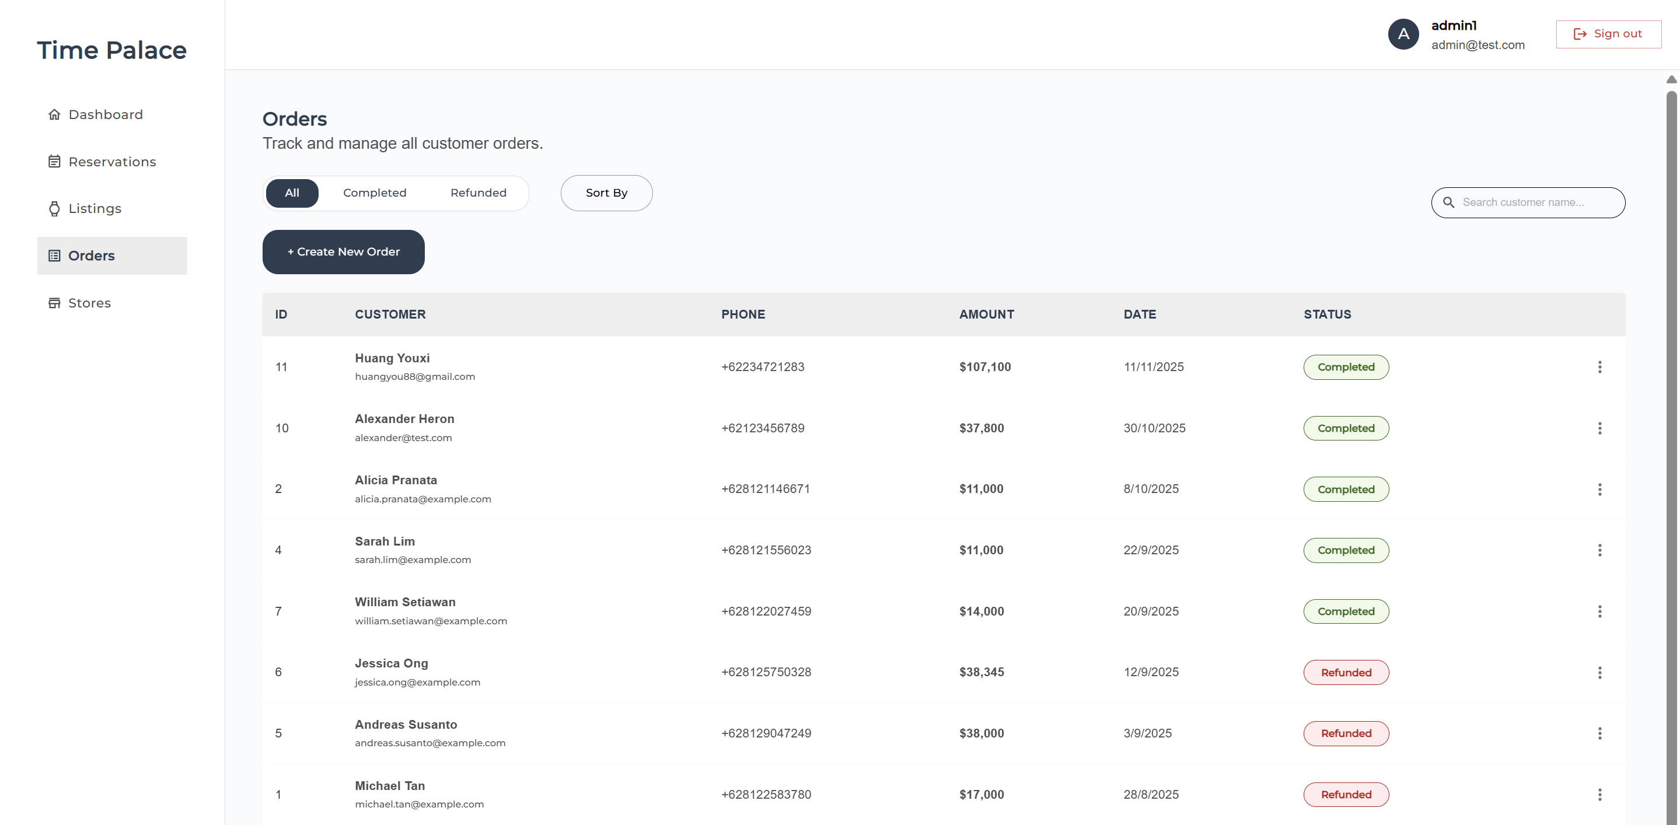

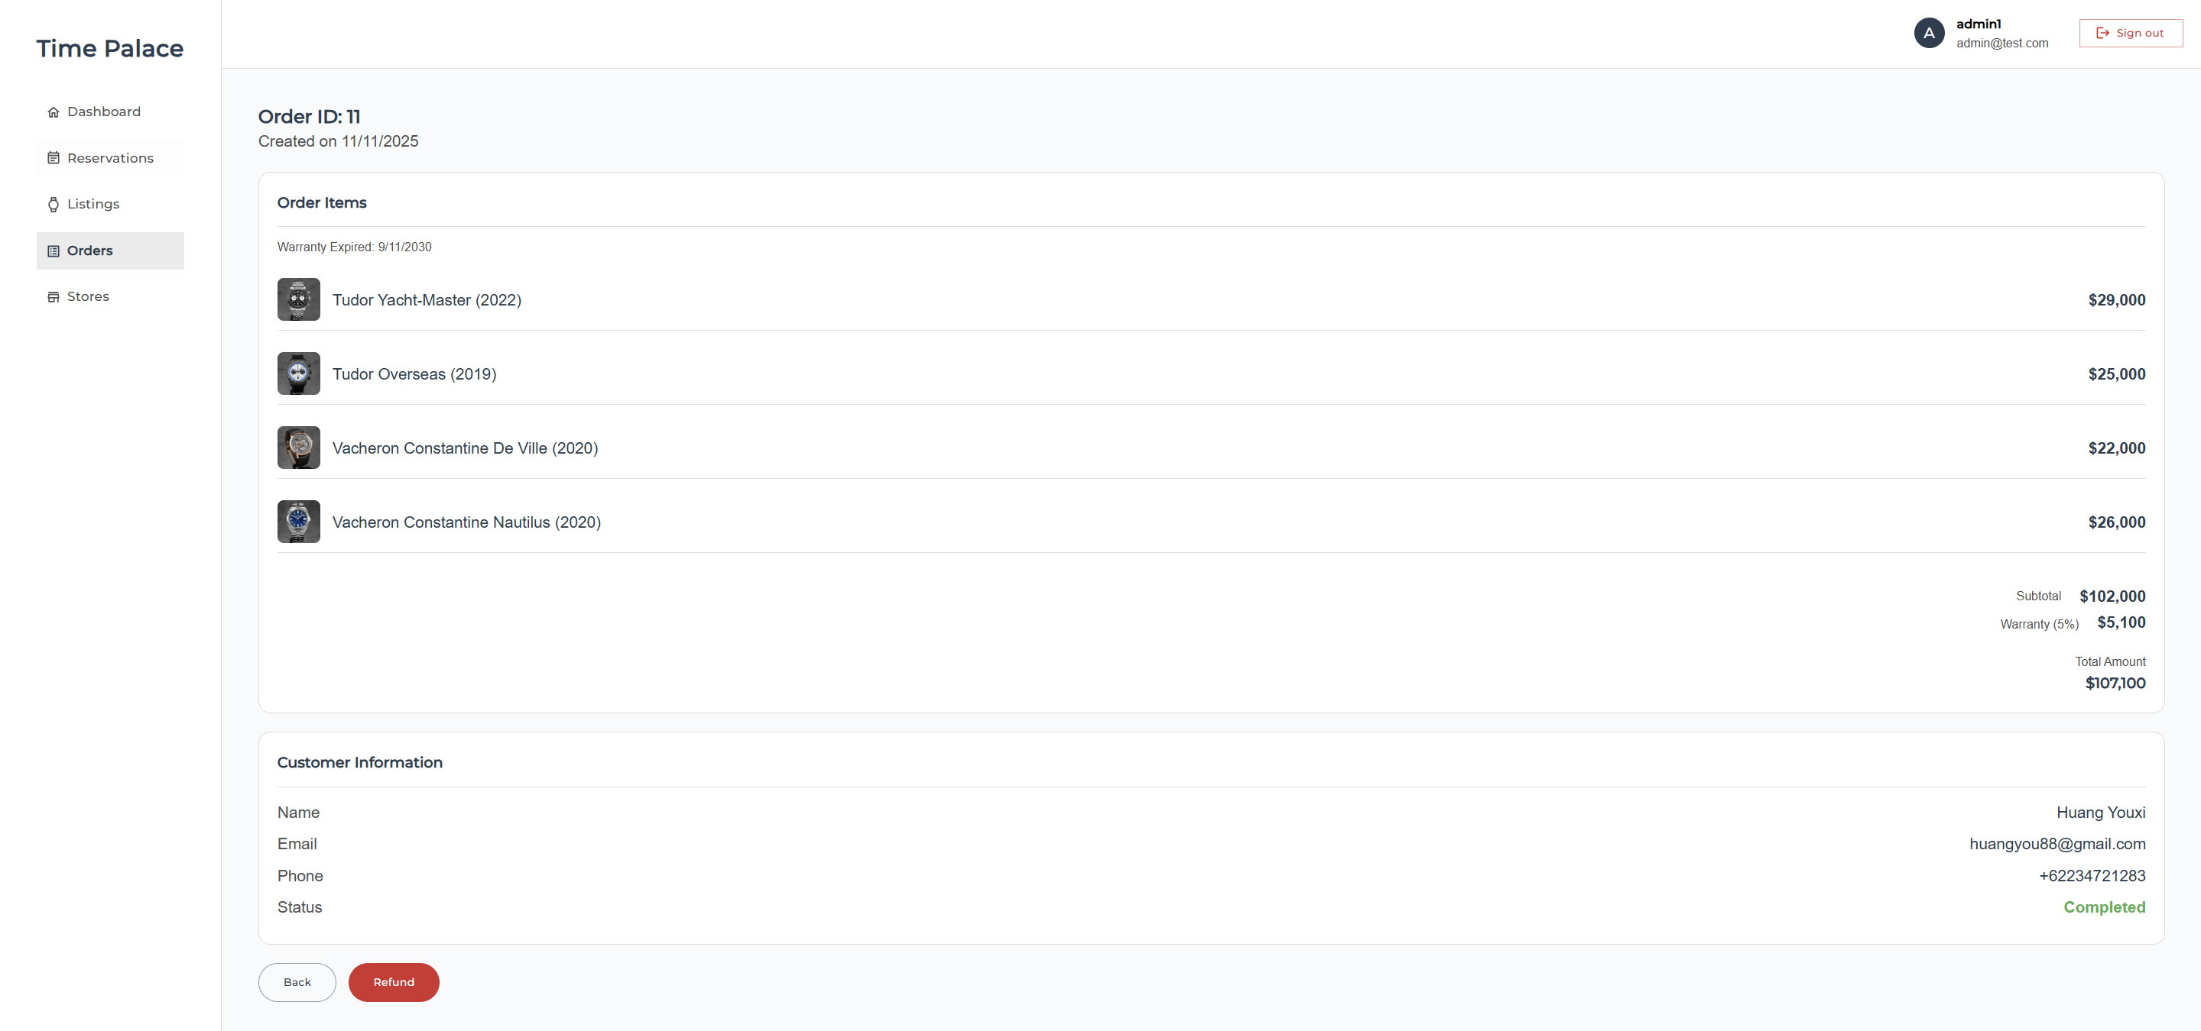

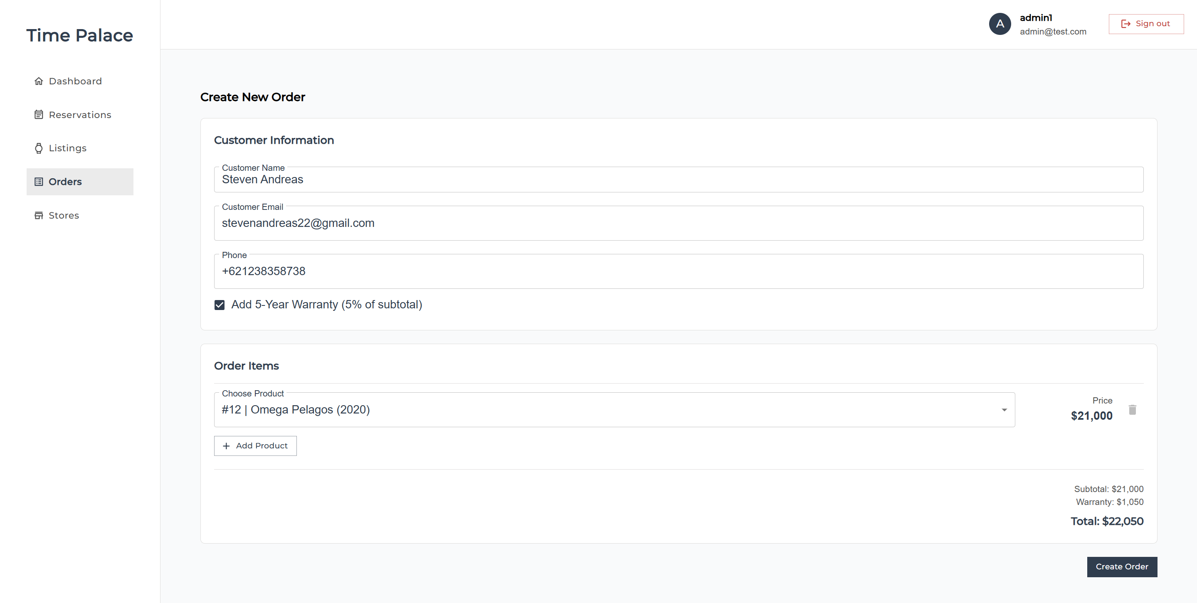

## 7. Performance and Optimization

### 7.1 Data Fetching Pagination

Pagination is implemented across multiple API functions, including watch listings, orders, and reservations. This approach ensures that the system retrieves only the necessary data for each page — rather than loading the entire dataset at once — keeping performance fast and lightweight on both the client and server.

For example, the getAllWatchListings() function uses Supabase’s range(from, to) method to limit query results per page, while also calculating the total number of items using count: "exact".

const from = (page - 1) * PAGE_SIZE;

const to = from + PAGE_SIZE - 1;

const { data, count } = await supabase

.from("watch_listings")

.select("*", { count: "exact" })

.range(from, to);

With this approach, the application loads only the data relevant to the active view, avoiding over-fetching, improving page load time, and maintaining system efficiency even as the dataset grows larger.

### 7.2 Query Caching and Prefetching

To maintain a fast and efficient user experience, the system uses React Query as its caching and data management layer.

This approach allows the application to instantly display previously cached data while automatically performing background refetches to keep the information up to date.

* Prefetching for fast page-to-page navigation

On pages such as the order list (useOrders) and watch listings (useWatchListings), the system performs prefetching for both the previous and next pages whenever the user changes the current page.

This ensures that when users click “Next” or “Previous,” the data is already cached and can be displayed immediately without additional loading time.

if (page < pageCount) {

queryClient.prefetchQuery({

queryKey: ["orders", filters, sortBy, page + 1],

queryFn: () => getOrders(filters, sortBy, page + 1, keyword),

});

}

* **Dynamic cache lifetime (staleTime)**  
  Certain data that rarely changes, such as the list of “available” watches, is assigned a staleTime of 5 minutes to prevent unnecessary repeated fetches to the server.

useQuery({

queryKey: ["available-watch-listings"],

queryFn: getAvailableWatchListings,

staleTime: 1000 * 60 * 5, // cache 5 menit

});

* **Global fallback stale policy**

By default, all queries use staleTime: 0, meaning the data is considered stale as soon as the component mounts — ensuring that critical information such as transactions and reservations is always fetched fresh from the server.

const queryClient = new QueryClient({

defaultOptions: {

queries: { staleTime: 0 },

},

});

This combined approach provides a balance between real-time accuracy and a fast user experience, depending on the context of the data being retrieved.

### 7.3 Server-side Data Aggregation

To improve performance and data-fetching efficiency, the system uses server-side data aggregation through a PostgreSQL view called orders_view.

This approach allows multiple tables — such as orders, order_items, and watch_listings — to be joined directly at the database level, eliminating the need for multiple API calls to retrieve complete order information.

Instead of making several separate requests (for example, one query for the order, another for the items, and another for the watches), all aggregation is handled within the database using json_agg() and json_build_object(), producing a JSON-formatted result that is immediately ready for the front-end to consume.

Here is the view definition:

create view public.orders_view as

select

o.id as order_id,

o.customer_name,

o.customer_email,

o.amount,

o.status,

o.created_at,

json_agg(

json_build_object(

'watch_id', w.id,

'watch_name', w.name,

'price', oi.price,

'image', w.image

)

) filter (where w.id is not null) as items

from orders o

left join order_items oi on oi.order_id = o.id

left join watch_listings w on w.id = oi.watch_id

group by o.id;

With this view in place, API functions such as getOrders() only need a single, simplified query.

const { data } = await supabase

.from("orders_view")

.select("order_id, customer_name, amount, status, items")

.order("created_at", { ascending: false });

This approach significantly reduces the number of queries the client must perform, as all data aggregation happens directly within the database. As a result, response times become much faster, and the returned data is already in a JSON format that matches the needs of the front-end.

By handling aggregation on the server side, the system ensures that the admin dashboard remains efficient and performant even as the volume of orders and items continues to grow.